July 27th, Friday Topic: past perfect

Get started : answer the questions

1 Do you think traveling is fun? Why or why not?

Read . What incident happened or nearly happened in each story?

Grammar Simple past and past perfect after/before + gerund (-ing form)

Comprehension

Match the stories (A–C) to the sentences (1–6).

1. Someone did something brave. B

2. There was a risk of fire. _____

3. People were traveling by sea. _____

4. A man saved another person’s life._____

5. Someone got wet. _____

6. Someone called the fire department. ____

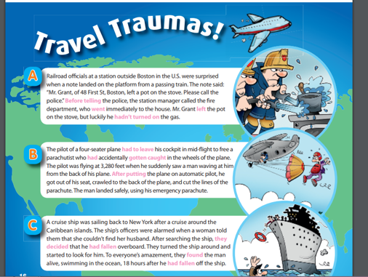

Write:

On the notebook, write a paragraph about a problem you had while traveling. Use the simple past and the past perfect.

Example: I had a problem on my trip to Los Angeles. The train ride was terrible because I had forgotten my money . . .